AIT 524: Weekly Assignment 06
Tanmoy Chowdhury
George Mason University

Author Note
This task is being submitted as an assignment task 06 for the course ‘Database Management Essential’ offered in Sprig 2018. For any kind of inquiry, feel free to contact at tchowdh6@masonlive.gmu.edu.

Online Drill
The ERD from assignment 04 has been used here. At the very beginning I put the lines which explain what I am going to retrieve. Then I wrote the query lines.
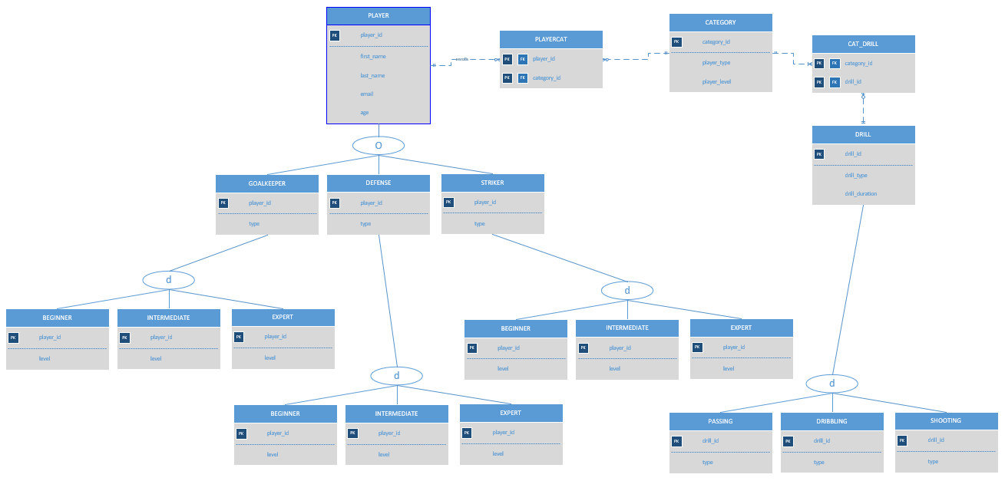
Figure 01: ERD from Assignment 04

Queries 1 - 3 must retrieve at least two attributes and must be based on a single table. Each query must include at least two conditions. Provide an explanation of what the query is retrieving. Use complete, coherent sentences with no database terminology.

- Retrieve Player ID and Email for the player whose name is John Smith.

PLYR <- σ first_name= John ^ last_name= Smith (PLAYER),
RESULT <- π _{player_id, email} (PLYR)

- Retrieve Player name (First and Last Name) for the player whose age is 20 and email is jsmth18@gmu.edu.

PLYR <- σ _{age= 20 ^ email=} jsmth18@gmu.edu (PLAYER),
RESULT <- π _{first_name, last_name} (PLYR)

- Retrieve Player age and Email for the player whose name is John Smith.

PLYR <- σ first_name= John ^ last_name= Smith (PLAYER),
RESULT <- π _{age, email} (PLYR)

Queries 4 - 6 must retrieve at least three attributes in total and must be based on two tables. Each query must include at least two conditions. Provide an explanation of what the query is retrieving. Use complete, coherent sentences with no database terminology.

- Retrieve Name (First and Last) of those players whose age is under 19 who’s category_id is 5.

PLYCT1 <- σ _{category_id = 5} (PLAYERCAT),
PLYR1 <- σ _{age<19} (PLAYER),
PLYR <- PLYR1 ⟕(PLYR1.player_id = PLYCT1.player_id) PLYCT1
RESULT <- π _{first_name, last_name} (PLYR)

- Retrieve category_id and drill id of those drills whose duration is under 20 minutes who’s type is dribbling.

DRL <- σ drill_duration <20 ^ drill_type = dribbling (DRILL),
DRL1 <- CAT_DRILL ⟕(CAT_DRILL.drill_id = DRL.drill_id) DRILL
RESULT <- π _{category_id, drill_id} (DRL1)

** Here basically DRL1 = RESULT. Last query is redundant. We can omit it. Because CAT_DRILL has only category_id and drill_id. So we do not need the last query.

- Retrieve player id and age of those players whose last name is smith and enrolled in category 4

PLYCT <- σ _{category_id = 4} (PALAYERCAT),
PLYR <- σ _{last_name = smith} (PALAYER),
PLYR2 <- PLYR ⟕(PLYR.player_id=PLYCT.category_id) PLYCT
RESULT <- π _{player_id, age} (PLYR2)

Queries 7 - 8 must retrieve at least three attributes in total and must be based on three tables. Each query must include at least two conditions. Provide an explanation of what the query is retrieving. Use complete, coherent sentences with no database terminology.

- Retrieve Player Name (First and Last) and ID of those players whose type is goalkeeper and level is beginner.

CAT <- σ player_type=goalkeeper ^ player_level=beginner (CATEGORY),
PLYR1 <- PLAYERCAT ⟕(PLAYERCAT.category_id = CAT.category_id) CAT
PLYR <- PLAYER ⟕(PLAYER.player_id = PLYR1.player_id) PLYR1
RESULT <- π first_name, last_name, player_id (PLYR)

- Retrieve Player Name (First and Last) and ID of those players whose type is striker and level is intermediate.

CAT <- σ player_type=striker ^ player_level=intermediate (CATEGORY),
PLYR1 <- PLAYERCAT ⟕(PLAYERCAT.category_id = CAT.category_id) CAT
PLYR <- PLAYER ⟕(PLAYER.player_id = PLYR1.player_id) PLYR1
RESULT <- π first_name, last_name, player_id (PLYR)

Queries 9 - 10 must be based on at least two tables, include at least two conditions, and one grouping function operator. Provide an explanation of what the query is retrieving. Use complete, coherent sentences with no database terminology.

- Retrieve player id and age of those players whose last name is smith and enrolled in category 4 . What is the average age of them.

PLYCT <- σ _{category_id = 4} (PALAYERCAT),
PLYR <- σ _{last_name = smith} (PALAYER),
PLYR2 <- PLYR ⟕(PLYR.player_id=PLYCT.category_id) PLYCT
RESULT1 <- π _{player_id, age} (PLYR2)
RESULT <- ℱ_{AVERAGE age} (RESULT1)

- Retrieve Name (First and Last) of those players whose age is under 19 who’s category_id is 5. Count their number also.

PLYCT1 <- σ _{category_id = 5} (PLAYERCAT),
PLYR1 <- σ _{age<19} (PLAYER),
PLYR <- PLYR1 ⟕(PLYR1.player_id = PLYCT1.player_id) PLYCT1
RESULT1 <- π _{first_name, last_name} (PLYR)
RESULT <- ℱ_{COUNT last_name} (RESULT1)

References
Elmasri, R., Navathe, S. B. (2016). Database system concepts and architecture in M. J. Horton, Fundamentals of Database Systems (7th ed.) : Pearson.

